***Spring Mvc***

***Firstly,***

***Client will make request in index.jsp and then it will go to to web.xml by the url***

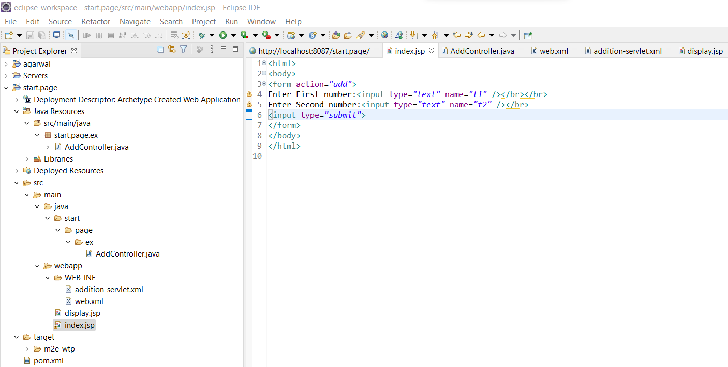

***Then, it will go to web.xml***

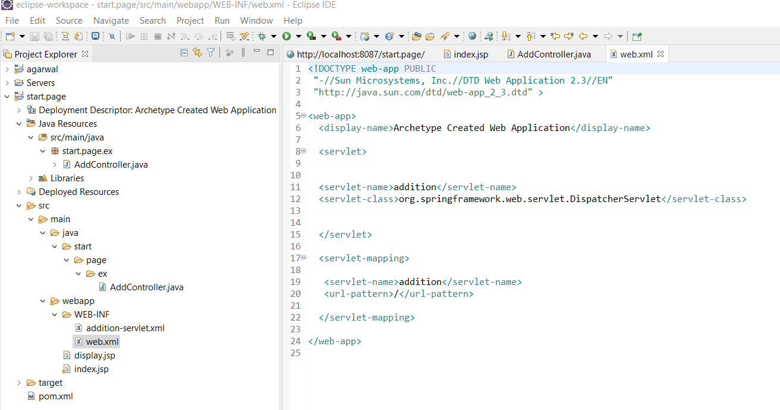

***Then it will go to dispatcher servlet that is present only web.xml only…after that dispatcher servlet will find Controller annotation .***

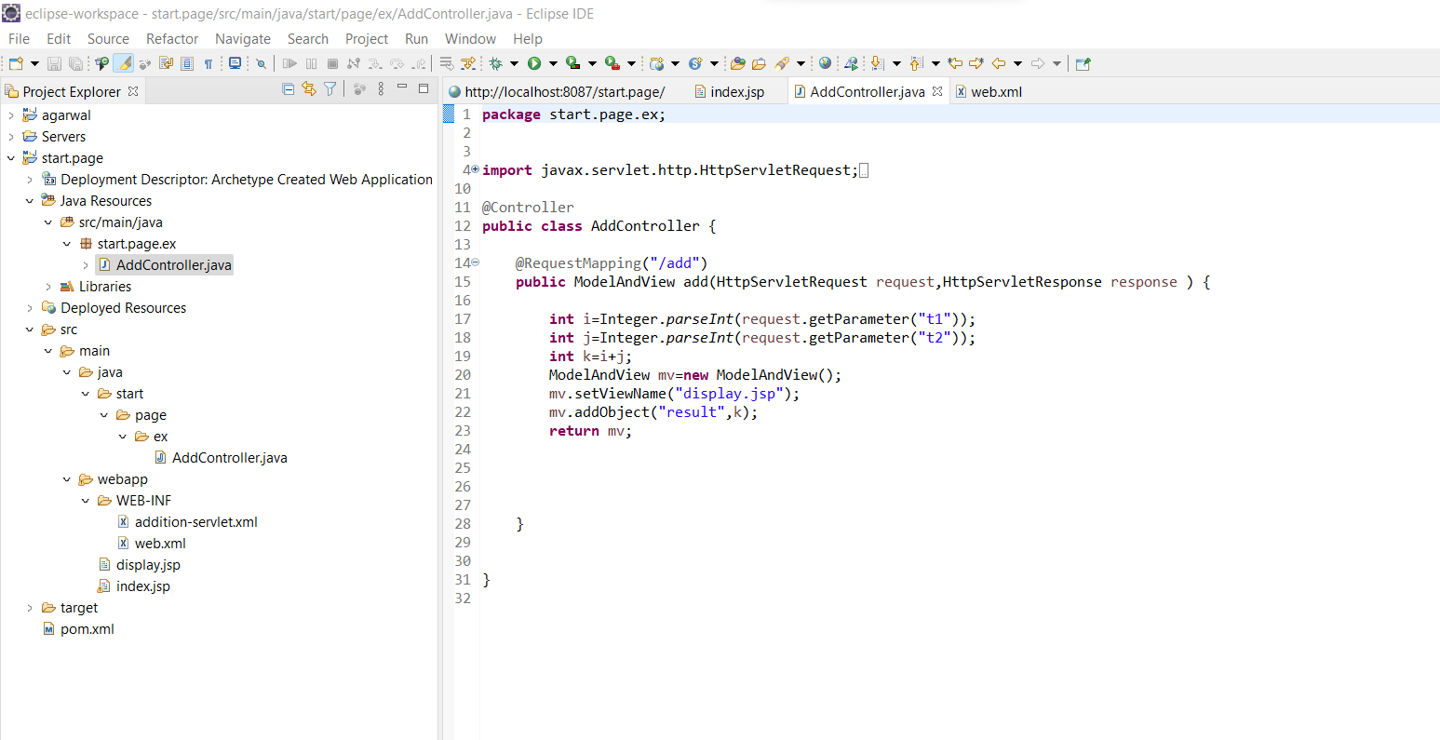***After that, it will check that it is same package that he looking for - in xml configuration file.***

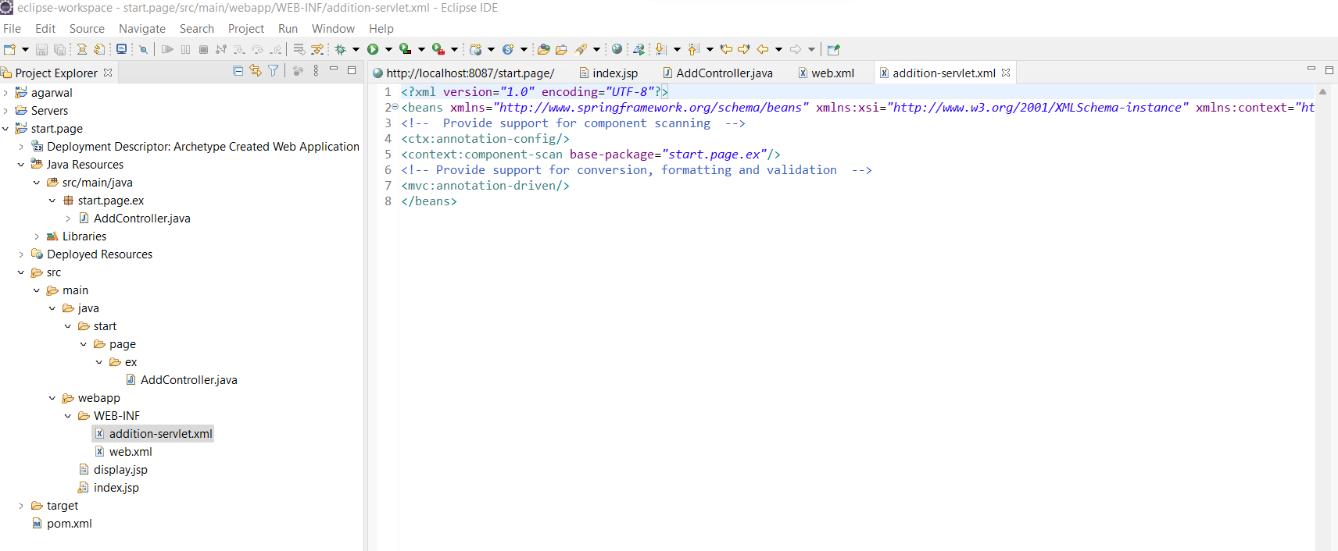

***Then it will go to display.jsp to display result.***

